USB Weigher Controller

Detail Design

1. Overview

The Cypress Semiconductor EZ-USB based “Weigher Controller” will provide the interface between the Evolution “Weigher Task” executing on the system controller and the actual weigher hardware. The “Weigher Controller” will receive and interpret messages from the “Weigher Task” via USB (Universal Serial Bus), read and control the A/D (Analog-to-Digital) converter, perform motion detection on the A/D counts, and supply feedback information to the “Weigher Task”.
Development will include porting the Analog Devices AD7730 A/D converter driver utilized in the SP600 and the Ultima “Weigher Controller” application to implement the peripheral function. Archor Chip’s Firmware FrameWorks will be the foundation for constructing this USB compliant peripheral device.
Because it is soft, the EZ-USB chip can take on the identities of multiple distinct USB devices. The first device downloads your 8051 firmware and USB descriptor tables over the USB cable when the peripheral device is plugged in. Once downloaded, another device comes on as a totally different USB peripheral as defined by the downloaded information. This two-step process, called ReNumeration™, happens instantly when the device is plugged in, with no hint that the initial load step has occurred. Chapter 5, "EZ-USB Enumeration and ReNumeration™" in the EZ-USB Technical Reference Manual describes this feature in detail, along with other EZ-USB boot (startup) modes.



Hobart Corporation
Troy, Ohio

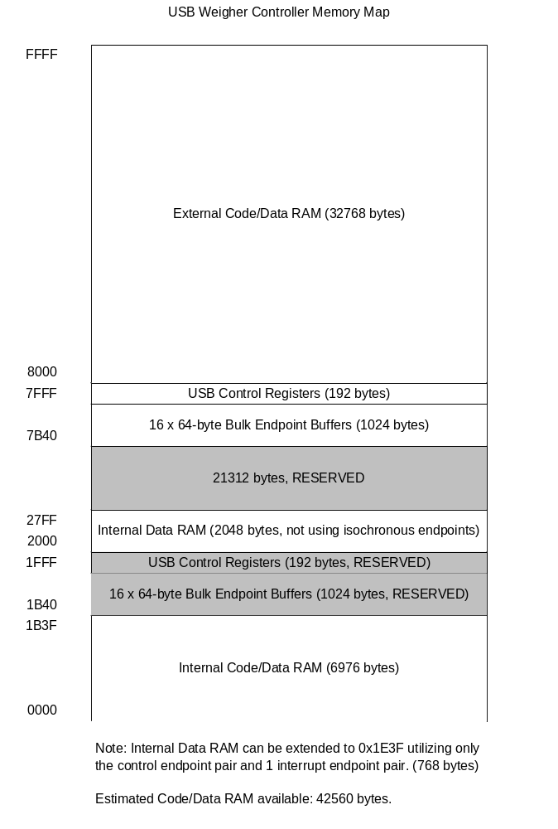2. System Diagram

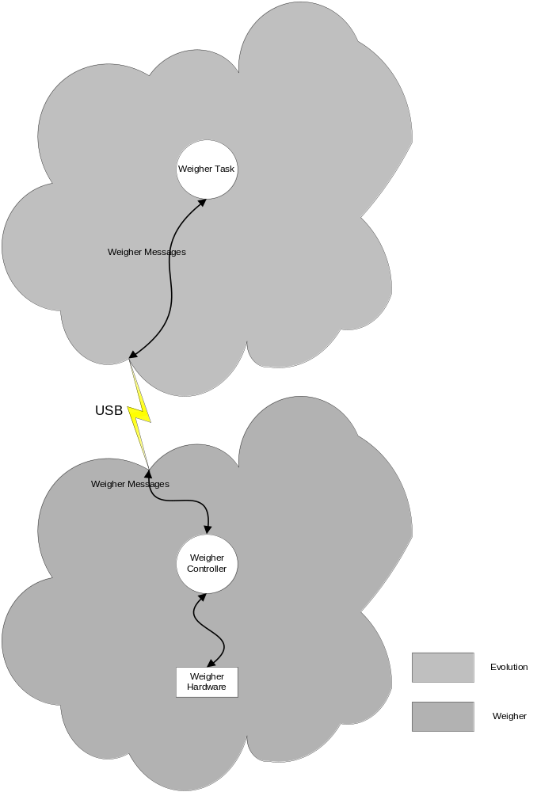

3. Functional Description

3.1. Data Flow Diagram – Level 1 (Co-operative Tasking Executive)
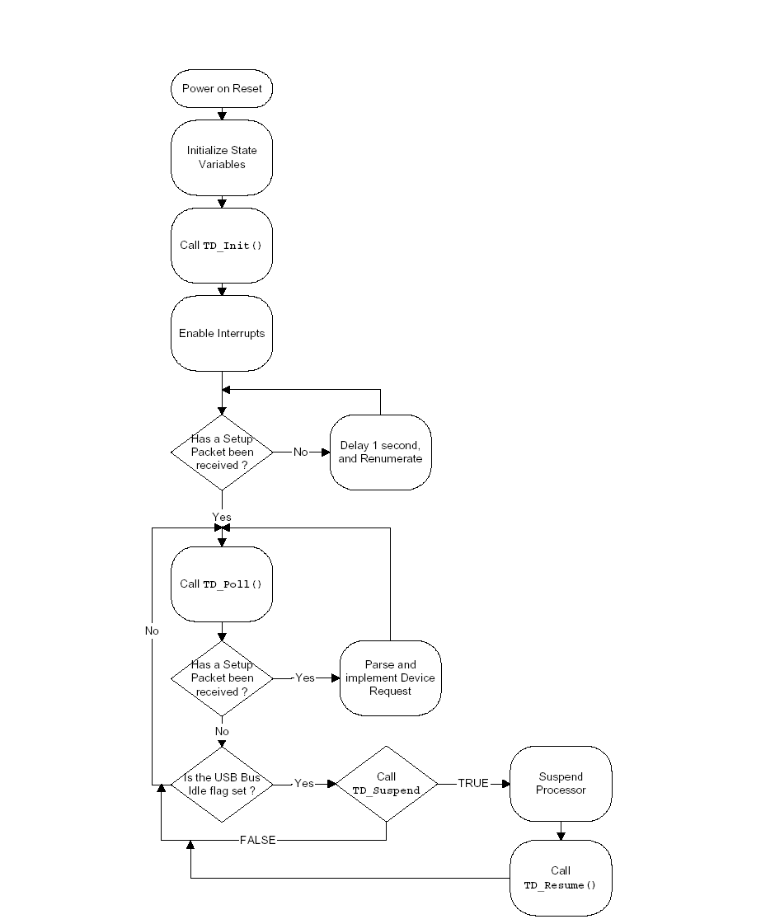

Data Flow Diagram – Level 2 (Parse and implement Device Request)

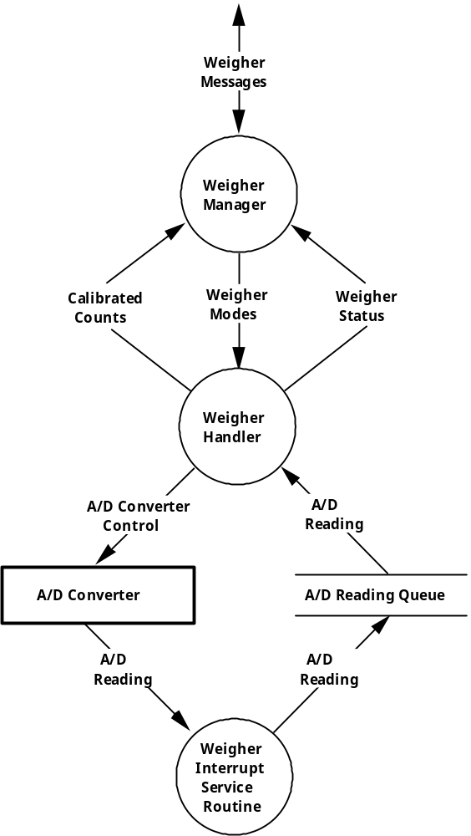

3.2. Performance

The A/D Converter of choice is the Analog Devices AD7730 sigma-delta A/D realizing up to 24 bits of no missing codes performance. This A/D features on-chip digital filtering, intended for the measurement of wide dynamic range, and low-frequency signals such as those necessary for weigh-scale applications. A digital low-pass filter processes the output of the sigma-delta modulator and updates the data register at a rate that can be programmed over the serial interface. The output data from the part is accessed over this serial interface. The AD7730 provides a number of calibration options which can be programmed via the MD2, MD1, and MD0 bits of the Mode Register.

The “Weigher Controller” will be capable of reading the A/D converter from 20 to 30 times a second while performing motion detection and some limited amount of software count filtering.

3.3. Calibration

The time required to perform the calibration calculations by the “Weigher Controller” will be greatly reduced by using only integer mathematics.

A/D readings from the proposed A/D converter will read as unsigned long integers with values ranging 0 to 16777216 (24 bit).

All calibration calculations will be done using unsigned long integer (32 bit) mathematics. Thus, the maximum value that can be maintained is 2^32 - 1 or a range of 0 to 4,294,967,295.

Calibrated counts will contain pseudo resolution to the one ten thousandth of a scale division due to the calibration method. This will also aid in the readability of the code as it must conform to Weights and Measures Handbook 44.

The Gain Factor will be calculated by the Evolution system controller using the following formula:

Desired Counts = the number of counts desired to receive for
a particular load, such as 300000 counts for
a 30 lb. load.

Zero Counts = the A/D Reading received from the A/D
converter with a zero load.

Actual Counts = the A/D Reading received from the A/D
converter with the actual load.

Gain Factor =
(Desired Counts / (Actual Counts - Zero Counts)) * 1000

Once calculated, the Gain Factor will then be sent to the Evolution “Weigher Task” via the communication link. The Calibration formula for the “Weigher Controller” then becomes:

A/D Reading = the value read from the A/D converter.

Calibrated Counts = (Gain Factor * A/D Reading) / 1000

Example:

Evolution System Controller Calculations

Zero Counts with no platter load:

Zero Counts = 12248

Actual Counts with 30 lbs. platter load:

Actual Counts = 40304

Desired Counts with 30 lbs. platter load:

Desired Counts = 300000

Gain Factor:

Gain Factor =
(Desired Counts / (Actual Counts - Zero Counts)} * 1000

Gain Factor = (300000 / (40304 - 12248)) * 1000

Gain Factor = (300000 / 28056) * 1000

Gain Factor = 10693

Weigher Controller Calculations

Calibrated Actual Counts for a 30 lbs. load

Calibrated Actual Counts =
(Gain Factor * (Actual Counts - Zero Counts)) / 1000

Calibrated Actual Counts = (10693 * (40304 - 12248)) / 1000

Calibrated Actual Counts = 300002

A/D readings will always be reported to the Evolution system controller after application of the Gain Factor or as Calibrated Counts.

By setting the Gain Factor to 1000, the “Weigher Controller’s” raw A/D Readings can be monitored.

3.4. Logical Interface

3.4.1. Messages to the Weigher Controller

3.4.1.1. WG_WAKEUP

This message will request a weigher wakeup message. The response will be a WG_WAKEUP message.

3.4.1.2. WG_CONFIG

This message will set the configuration of the weigher. This change in configuration can be permanent (written to EEP and RAM) or temporary (written only to RAM) as indicated within the message. There will be no direct response to this message.

3.4.1.3. WG_INQUIRE

This message will request the configuration of the weigher. The response message will be a WG_INQUIRE message.

3.4.1.4. WG_MODE

This message will set the mode in which the weigher must return unsolicited weigher status messages to the Evolution system controller. There will be no direct response to this message.

3.4.1.5. WG_RESET

This message will software reset the weigher and clear any error conditions. There will be no direct response to this message.

3.4.1.6. WG_STATUS

This message will request weigher status. The response will be a WG_STATUS message.

3.4.1.7. WG_ENABLE

This message will enable the weigher. There will be no direct response to this message.

3.4.1.8. WG_DISABLE

This message will disable the weigher. The response to this message will be a WG_STATUS message indicating that the weigher is disabled.

3.4.1.9. WG_REZERO

This message will initiate the weigher to select a new zero value. The response will be a WG_STATUS message indicating that a new zero has been selected.

3.4.1.10. WG_CONTROL

This message will initiate a write of data contained in the message to the A/D control register. This message is used primarily for manufacturing test. There will be no direct response to this message.

3.4.2. Messages from the Weigher Controller

3.4.2.1. WG_INQUIRE

This message will return the current configuration of the weigher.

3.4.2.2. WG_STATUS

This message will return the weigher status. In addition, this message will also contain the current calibrated raw counts, and the current target (weight) counts.

3.4.2.3. WG_WAKEUP

This message will return the weigher system status at power up.

3.5. Description of Messages from the Weigher Controller

3.5.1 Status, Wakeup, and Inquire Messages

Status Message: (12 bytes)

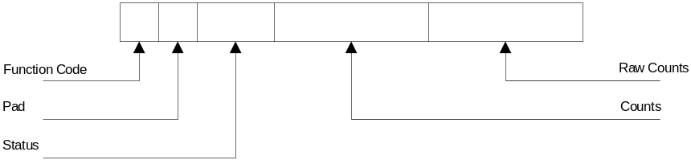

Function Code Field: (byte) 0x04
Pad Field: (byte) N/A
Status Field: (2 bytes) Current weigher status

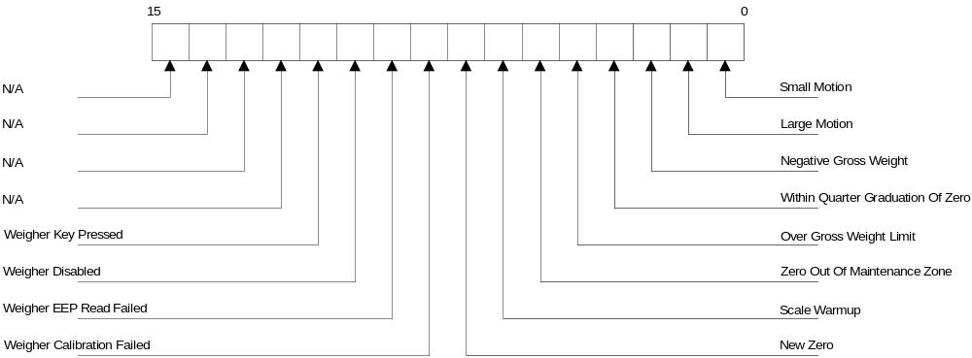
Small Motion Field: Set when there is small motion after multiple weigher readings. (0x0001)
Large Motion Field: Set when there is large motion in multiple weigher readings or there is a gradual change in the same direction for multiple readings. (0x0002)
Negative Gross Weight Field: Set when there is a negative weight reading from the weigher. (0x0004)
Within Quarter Graduation Of Zero Field: Set when the weigher A/D reading is less than 25. (0x0008)
Over Gross Weight Limit Field: Set when weight on the weigher exceeds the max weight limit for the weigher. (0x0010)
Zero Out Of Maintenance Zone Field: Set when the weigher’s zero delta is greater than maintenance zone limit. (0x0020)
Scale Warmup Field: Set when the weigher is warming up. (0x0040)
New Zero Field: Set when the weigher needs to be zeroed. (0x0080)
Weigher Calibration Field: Set when the zero reference calibration of the A/D converter has failed. (0x0100)
Weigher EEP Read Failed Field: Set when the weigher has failed to read the weigher EEPROM’s checksum correctly. (0x0200)
Weigher Disable Field: Set when a weigher disable message is received or while the weigher is performing a hardware reference calibration on the weigher A/D converter. (0x0400)
Weigher Key Pressed Field: Set when the weigher key has been pressed. (0x0800)
Counts Field: (4 bytes) Absolute value of the A/D minus the zero value.
Raw Counts Field: (4 bytes) Unfiltered value of the A/D.

Wakeup Message: (3 bytes)

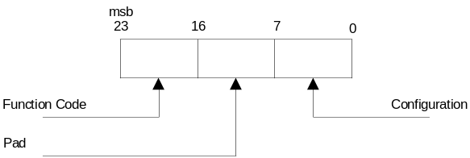

Function Code Field: (byte) 0x00
Pad Field: (byte) N/A
Configuration Field: (byte) Status of the weigher initialization. A bad read of the weigher’s EEPROM checksum will result in an error (invalid = 1) because the configuration information for the weigher is stored on the on board EEPROM and the weigher uses this information to initialize itself on power up (valid = 0).

Inquire Message: (95 bytes)

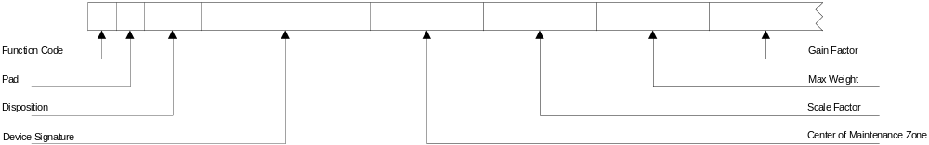

Function Code Field: (byte) 0x02
Pad Field: (byte) N/A
Disposition Field: (byte) Tells if the configuration is 0 = valid, 1 = Error
Device Signature Field: (6 bytes) 0x00
Center Of Maintenance Zone Field: (4 bytes)
Scale Factor Field: (4 bytes) Default value of 1.
Max Weight Field: (4 bytes) Default value of 900000. Used to determine if the package on the weigher is over the gross weight of the scale. The value is in calibrated counts.
Gain Factor Field: (4 bytes) Is a fudge factor to calibrate the A/D counts. Default is 10000 but since we divide by 1000, it really a factor of 10.

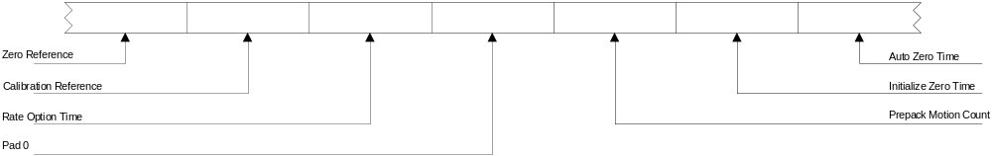
Zero Reference Field: (4 bytes) Also a fudge factor. This is an offset value used give a true zero reading.
Calibration Reference Field: (4 bytes) The measured zero calibration reference.
Rate Option Time Field: (4 bytes) Rate Option time is based in seconds. It is used to set the weigher time constant for the period of time that successive weigher readings are examined for stability. This is preformed to allow the weigher electronics to warm up before any weighing begins.
Pad0 Field: (4 bytes) N/A
Prepack Motion Count Field: (4 bytes) Time required to get accurate weight measurements while in prepack mode. To be in prepack mode means that the weigher will only send a weigher status when there is some change to weigher status.
Initialize Zero Time Field: (4 bytes) Time the weigher monitors the A/D readings for stability. Once the readings have remained stable for this time period, a new zero is selected. This value is based in seconds.
Auto Zero Time Field: (4 bytes) Time for the weigher to perform an auto zero. This value is based in seconds.

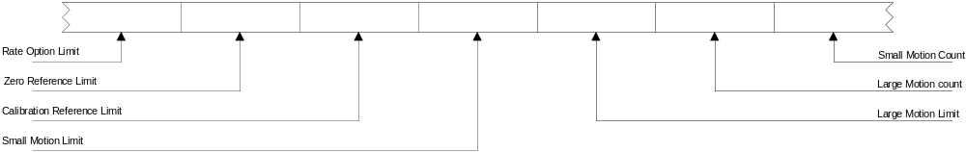
Rate Option Limit Field: (4 bytes) N/A
Zero Reference Limit Field: (4 bytes) Checked during weigher calibration of its zero reference. This value is checked against a raw A/D count to insure a valid zero reading.
Calibration Reference Limit Field: (4 bytes)
Small Motion Limit Field: (4 bytes) Used to check if still detecting large motion. This is the small motion threshold.
Large Motion Limit Field: (4 bytes) Threshold between large motion and small motion. Readings less than the large motion limit means that we have detected a small motion.
Large Motion Count Field: (4 bytes)
Small Motion Count Field: (4 bytes)

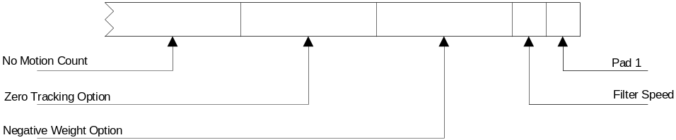

No Motion Count Field: (4 bytes) Timer value that is loaded when there is no motion.
Zero Tracking Option Field: (4 bytes) N/A
Negative Weight Option Field: (4 bytes) N/A
Filter Speed Field: (byte) A/D filter speed 0x00 = normal filter speed, 0x01 = slow filter speed default is slow filter speed.
Pad 1 Field: (byte) N/A

3.5.2. Target

Reported with weigher status will be the current Target value. The Target can be thought of as the weight on the scale. This count value has been calibrated, filtered and had the Zero subtracted. The Zero being the Calibrated Counts received from the A/D converter with a zero load on the scale.

3.5.3. Raw Counts

Also reported with weigher status will be the current Raw Counts value. This count value is the last received Calibrated Counts from the A/D converter. This value has not had the Zero subtracted.

3.5.4. Modes

The manner in which Weigher Status will be reported to the Evolution system controller will be based on one of the following Weigher Modes:

3.5.4.1. Tracking Mode

Weigher Status will be sent at some modulo interval of readings from the A/D converter. (i.e. Every sixth reading will initiate a Weigher Status message.) Since this A/D converter will be read as many as 30 times per second, sending Weigher Status with every reading would degrade system communication performance.

3.5.4.2. Prepack Mode

Weigher Status will be sent only when there is some change in Weigher Status. Motion criteria is less sensitive than Manual Mode to allow for the faster stabilization of valid weights.

3.5.4.3. Dumb Mode

Weigher Status will only be sent when requested explicitly.

3.5.4.4. Manual Mode

Weigher Status will be sent only when there is some change in Weigher Status. Motion criteria is much more sensitive than Prepack Mode to eliminate thumb weighing.

4. Detail Description

4.1. Program Structure (Peripheral Function)

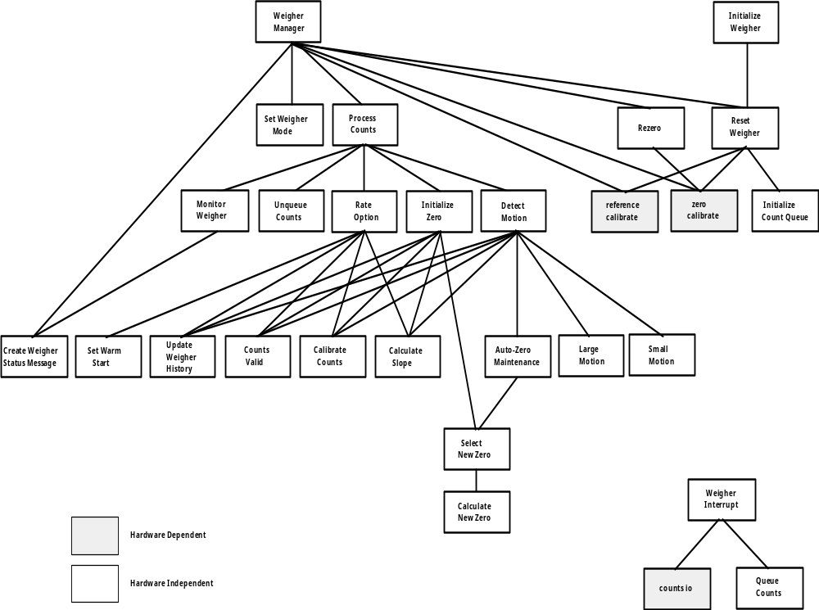

4.2. Data Structures

/* Weigher Status Bit Definitions */

#define WEIGHER_DISABLED 0x0800
#define CALIBRATION_CHECK_FAILED 0X0400
#define WEIGHER_EEP_READ_FAILED 0X0200
#define UNDER_RANGE 0X0100
#define NEW_ZERO 0X0080
#define SCALE_WARMUP 0X0040
#define ZERO_OUT_OF_MAINTENANCE_ZONE 0X0020
#define OVER_GROSS_WEIGHT_LIMIT 0X0010
#define WITHIN_QUARTER_GRAD_OF_ZERO 0X0008
#define NEGATIVE_GROSS_WEIGHT 0X0004
#define LARGE_MOTION 0X0002
#define SMALL_MOTION 0X0001

/* Message Definitions */

enum wg_message_code { WG_WAKEUP,
WG_CONFIG,
WG_INQUIRE,
WG_MODE,
WG_RESET,
WG_STATUS,
WG_ENABLE,
WG_DISABLE,
WG_REZERO,
WG_CALIBRATE,
WG_CHECK };
typedef enum wg_message_code WgMessageCode;

/* Generic */

struct wg_generic
{
WgMessageCode function_code;
BYTE pad0;
};
typedef struct wg_generic WgGeneric;

/* WakeUp */

struct wg_wakeup
{
WgMessageCode function_code;
BYTE pad0;
};
typdef struct wg_wakeup WgWakeup;

/* Config */

struct wg_configuration
{
UCHAR device_signature [DEVICE_SIG_NAME_LEN];
LINT center_of_maintenance_zone;
LINT scale_factor;
LINT max_weight;
LINT gain_factor;
UINT initialize_zero_time;
UINT auto_zero_maintenance_time;
UINT rate_option_limit;
UINT small_motion_limit;
UINT large_motion_limit;
UINT large_motion_count;
UINT zero_tracking_option;
UINT negative_weight_option;
};
typdef struct wg_configuration WgConfiguration;

struct wg_config
{
WgMessageCode function_code;
UCHAR pad0;
UINT disposition
WgConfiguration config;
};
typedef struct wg_config WgConfig;

struct wg_inquire
{
WgMessageCode function_code;
UCHAR pad0;
UINT disposition
WgConfiguration config;
};
typedef struct wg_inquire WgInquire;

/* Mode */

enum weigher_mode { SCALE_PREPACK_MODE,
SCALE_WEIGHT_TRACKING_MODE,
SCALE_DUMB_MODE,
SCALE_MANUAL_MODE };
typedef enum weigher_mode WeigherMode;

struct wg_mode
{
WgMessageCode function_code;
UCHAR pad0;
WeigherMode mode;
UCHAR pad1;
};
typedef struct wg_mode WgMode;

/* Reset */

struct wg_reset
{
WgMessageCode function_code;
UCHAR pad0;
};
typedef struct wg_reset WgReset;

/* Status */

struct wg_status
{
WgMessageCode function_code;
UCHAR pad0;
BITS status;
LINT target;
LINT raw_counts;
};
typedef struct wg_status WgStatus;

/* Enable */

struct wg_enable
{
WgMessageCode function_code;
UCHAR pad0;
};
typedef struct wg_enable WgEnable;

/* Disable */

struct wg_disable
{
WgMessageCode function_code;
UCHAR pad0;
};
typedef struct wg_disable WgDisable;

/* Re-zero */

struct wg_rezero
{
WgMessageCode function_code;
UCHAR pad0;
};
typedef struct wg_rezero WgRezero;

/* Calibrate */

struct wg_calibrate
{
WgMessageCode function_code;
UCHAR pad0;
};
typedef struct wg_calibrate WgCalibrate;

/* Check */

struct wg_check
{
WgMessageCode function_code;
UCHAR pad0;
};
typedef struct wg_check WgCheck;

/* Weigher Messages */

union wg_message
{
WgGeneric generic;
WgWakeup wakeup;
WgConfig config;
WgInquire inquire;
WgMode mode;
WgReset reset;
WgStatus status;
WgEnable enable;
WgDisable disable;
WgRezero rezero;
WgCalibrate calibrate;
WgCheck check;
};
typdef union wg_message WgMessage;

/* A/D readings structure */

struct atod_type
{
LINT counts;
BOOL polarity;
BOOL overrange;
};
typedef struct atod_type AtoDType;

/* Structures to hold history */

struct weigher_state_type
{
LINT zeroed_counts;
LINT unzeroed_counts;
BITS status;
BOOL slope;
};
typedef struct weigher_state_type WeigherStateType;

4.3. Weigher States

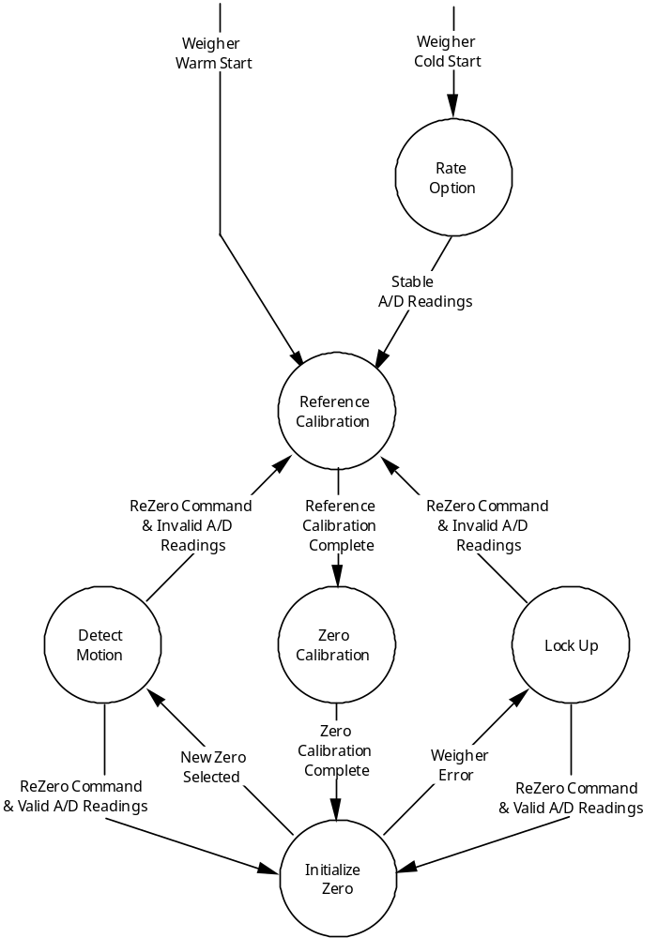

4.4. Module - wg_init.c

This file contains those routines used to initialize the Weigher Controller:

VOID InitializeWeigherHardware ();
CommHeader *InitializeWeigher ();

4.5. Module - wg_mgr.c

This file contains those routines responsible for Weigher Controller message handling:

CommHeader *WeigherManager ();
CommHeader *MonitorWeigher ();
CommHeader *WeigherStatusMessage ();
CommHeader *WeigherInquireMessage ();
CommHeader *WeigherWakeupMessage ();

4.6. Module - wg_hand.c

This file contains those routines responsible for handling the weigher reading processing:

VOID InitWeigherHandler ();
VOID DisableWeigher ();
VOID EnableWeigher ();
VOID WeigherInterrupt ();
VOID ReadWeigher ();
VOID ResetWeigher ();
VOID ProcessCounts ();
VOID LockUp ();
VOID RateOption ();
VOID ReferenceCalibration ();
VOID ZeroCalibration ();
VOID InitializeZero ();
VOID DetectMotion ();
BOOL LargeMotion ();
BOOL SmallMotion ();
BOOL AutoZero ();
BOOL ValidZero ();
VOID UpdateWeigherHistory ();
UCHAR CalculateSlope ();
LINT CalibrateCounts ();
VOID ReZero ();
VOID SetWeigherTimeConstants ();
BOOL QueueCount ();
BOOL UnQueueCount ();
VOID InitializeCountQueue ();
VOID InitializeWeigherKey ();
VOID ReadWeigherKey ();

4.7. Module - wg_io.c

This file contains those routines responsible for weigher controller input and output:

LINT ReadWeigherCounts ();
LINT read_weigher_counts ();
VOID ReferenceCalibrate ();
BOOL ReferenceCalibrateComplete ();
VOID reference_calibrate ();
VOID ZeroCalibrate ();
BOOL ZeroCalibrateComplete ();
VOID zero_calibrate ();
VOID SwitchReferenceVoltage ();
VOID switch_reference_voltage ();
VOID write_AD_control ();
VOID AD_control_io ();
VOID TestWeigherControl ();

4.8. Module - wg_eep.c

This file contains those routine responsible for setting the weigher controller default configuration:

VOID SetWeigherConfiguration ();

4.9. Anchor Firmware FrameWorks
4.9.1 Module Descriptions
reg80320.h: 8051 register declarations and bit mask constants (provided by Keil)
Ezusb.h: Common Anchor EZ-USB constants, macros, data types, and library function
prototypes
Ezregs.h: EZ-USB register declarations and bit mask constants
Fw.c: FrameWorks source code
Periph.c: User function hook definitions
Startup.a51: FrameWorks startup code (slightly modified version of Keil’s startup.a51)
Dscr.a51: Example USB descriptor table
Ezusb.lib: EZUSB library object code (see the library section for more details)
Build.bat: Batch file that builds the FrameWorks
Makefile: Borland 3.1 makefile that build the FrameWorks

4.9.2 FrameWorks Function Hooks
The FrameWorks provides function hooks to simplify the addition of user code. The functions are divided into three catagories; those called by the task dispatcher, the standard device request parser, and the USB interrupt handler. Each section following contains a complete list of functions and their descriptions.

Task Dispatcher
void TD_Init(void)
Description: This function is called once during the initialization of the FrameWorks. It is called prior to re-enumeration and the Task Dispatcher starting. It is intended for user global state variable initialization.
void TD_Poll(void)
Description: This function is called repeatedly during device operation. It should contain a state machine that implements the user’s peripheral function. High priority tasks may be completed prior to returning from this function. However, failure to return from this function will prevent FrameWorks from responding to device requests and USB suspend events. If a large amount of processing time is required, it must be split up to execute in multiple calls to TD_Poll().
BOOL TD_Suspend(void)
Description: This function is called prior to the FrameWorks entering suspend mode. This function should contain code that places the device in a low power state and returns TRUE. However, the user code may prevent the FrameWorks from entering suspend mode by returning FALSE.
void TD_Resume(void)
Description: This function is called after the FrameWorks has resumed the processor in response to an external resume event. At this point, the device may resume full power operation.

Device Request
BOOL DR_GetDescriptor(void)
Description: This function is called prior to the FrameWorks decoding and implementing the Get Descriptor device request. The register array SETUPDAT contains the current eight byte setup command. It may be parsed by the user’s code to determine which Get Descriptor command was issued. If TRUE is returned, the FrameWorks will parse and implement the command. If FALSE is returned, it will do nothing.
BOOL DR_GetInterface(void)
Description: This function is called prior to the FrameWorks implementing the Get Interface device request. The register array SETUPDAT contains the current eight byte setup command. If TRUE is returned, the FrameWorks will implement the command. If FALSE is returned, it will do nothing.
BOOL DR_SetInterface(void)
Description: This function is called prior to the FrameWorks implementing the Set Interface device request. The register array SETUPDAT contains the current eight byte setup command. By default, the FrameWorks parses the descriptor table to determine the new interface endpoints (See the section on FrameWorks optimization for more details). It then configures the EZUSB control registers to reflect these new endpoints. If TRUE is returned, the FrameWorks will implement the command. If FALSE is returned, it will do nothing.
BOOL DR_GetConfiguration(void)
Description: This function is called prior to the FrameWorks implementing the Get Configuration device request. The register array SETUPDAT contains the current eight byte setup command. If TRUE is returned, the FrameWorks will implement the command. If FALSE is returned, it will do nothing.
BOOL DR_SetConfiguration(void)
Description: This function is called prior to the FrameWorks implementing the Set Configuration device request. The register array SETUPDAT contains the current eight byte setup command. By default, the FrameWorks parses the descriptor table to determine the new configuration interface and its endpoints (See the section on FrameWorks optimization for more details). It then configures the EZ-USB control registers to reflect these new endpoints. If the configuration is set to 0 then the FrameWorks will invalidate all of the endpoints. If TRUE is returned, the FrameWorks will implement the command. If FALSE is returned, it will do nothing.
BOOL DR_GetStatus(void)
Description: This function is called prior to the FrameWorks implementing the Get Status device request. The register array SETUPDAT contains the current eight byte setup command. If TRUE is returned, the FrameWorks will implement the command. If FALSE is returned, it will do nothing.
BOOL DR_ClearFeature(void)
Description: This function is called prior to the FrameWorks implementing the Clear Feature device request. The register array SETUPDAT contains the current eight byte setup command. If TRUE is returned, the FrameWorks will implement the command. If FALSE is returned, it will do nothing.
BOOL DR_SetFeature(void)
Description: This function is called prior to the FrameWorks implementing the Set Feature device request. The register array SETUPDAT contains the current eight byte setup command. If TRUE is returned, the FrameWorks will implement the command. If FALSE is returned, it will do nothing.
void DR_VendorCmnd(void)
Description: This function is called when the FrameWorks determines a vendor specific command has been issued. The register array SETUPDAT contains the current eight byte setup command. This function has no return value. The FrameWorks does not implement any vendor specific commands. However, the EZ-USB serial interface engine (SIE) uses vendor specific command 0xA0 to implement software uploads and downloads. Therefore, command 0xA0 will not be passed to the user’s code.

USB Interrupt
void INT_Sudav(void)
Description: This function is called upon reception of the Setup Data Available interrupt. It is called within the interrupt handler itself. During operation of the function USB and lower priority interrupts will be disabled.
void INT_Sutok(void)
Description: This function is called upon reception of the Setup Token interrupt. It is called within the interrupt handler itself. During operation of the function USB and lower priority interrupts will be disabled.
void INT_Sof(void)
Description: This function is called upon reception of the Start of Frame interrupt. It is called within the interrupt handler itself. During operation of the function USB and lower priority interrupts will be disabled.
void INT_Susp(void)
Description: This function is called upon reception of the USB Suspend interrupt. It is called within the interrupt handler itself. During operation of the function, USB and lower priority interrupts are disabled.
void INT_UReset(void)
Description: This function is called upon reception of the USB Reset interrupt. It is called within the interrupt handler itself. During operation of the function, USB and lower priority interrupts are disabled.
void INT_Ep0In(void)
Description: This function is called upon reception of the Endpoint 0 Data I n interrupt. It is called within the interrupt handler itself. During operation of the function, USB and lower priority interrupts are disabled.
void INT_Ep0Out(void)
Description: This function is called upon reception of the Endpoint 0 Data Out interr upt. It is called within the interrupt handler itself. During operation of the function, USB and lower priority interrupts are disabled.
void INT_Ep1In(void)
Description: This function is called upon reception of the Endpoint 1 Data In interrupt. It i s called within the interrupt handler itself. During operation of the function, USB and lower priority interrupts are disabled.
void INT_Ep1Out(void)
Description: This function is called upon reception of the Endpoint 1 Data Out interrupt. It is called within the interrupt handler itself. During operation of the function, USB and lower priority interrupts are disabled.
void INT_Ep2In(void)
Description: This function is called upon reception of the Endpoint 2 Data In interrupt. It is called within the interrupt handler itself. During operation of the function, USB and lower priority interrupts are disabled.
void INT_Ep2Out(void)
Description: This function is called upon reception of the Endpoint 2 Data Out interrupt. It is called within the interrupt handler itself. During operation of the function, USB and lower priority interrupts are disabled.
void INT_Ep3In(void)
Description: This function is called upon reception of the Endpoint 3 Data In interrupt. It is called within the interrupt handler itself. During operation of the function, USB and lower priority interrupts are disabled.
void INT_Ep3Out(void)
Description: This function is called upon reception of the Endpoint 3 Data Out interrupt. It is called within the interrupt handler itself. During operation of the function, USB and lower priority interrupts are disabled.
void INT_Ep4In(void)
Description: This function is called upon reception of the Endpoint 4 Data In interrupt. It is called within the interrupt handler itself. During operation of the function, USB and lower priority interrupts are disabled.
void INT_Ep4Out(void)
Description: This function is called upon reception of the Endpoint 4 Data Out interrupt. It is called within the interrupt handler itself. During operation of the function, USB and lower priority interrupts are disabled.
void INT_Ep5In(void)
Description: This function is called upon reception of the Endpoint 5 Data In interrupt. It is called within the interrupt handler itself. During operation of the function, USB and lower priority interrupts are disabled.
void INT_Ep5Out(void)
Description: This function is called upon reception of the Endpoint 5 Data Out interrupt. It is called within the interrupt handler itself. During operation of the function, USB and lower priority interrupts are disabled.
void INT_Ep6In(void)
Description: This function is called upon reception of the Endpoint 6 Data In interrupt. It is called within the interrupt handler itself. During operation of the function, USB and lower priority interrupts are disabled.
void INT_Ep6Out(void)
Description: This function is called upon reception of the Endpoint 6 Data Out interrupt. It is called within the interrupt handler itself. During operation of the function, USB and lower priority interrupts are disabled.
void INT_Ep7In(void)
Description: This function is called upon reception of the Endpoint 7 Data In interrupt. It is called within the interrupt handler itself. During operation of the function, USB and lower priority interrupts are disabled.
void INT_Ep7Out(void)
Description: This function is called upon reception of the Endpoint 7 Data Out interrupt. It is called within the interrupt handler itself. During operation of the function, USB and lower priority interrupts are disabled.

4.9.3 FrameWorks Global Variables
The FrameWorks has several global variables that reflect the state of the USB device. The following lists the globals by name and describes their use.
Name Type Initial Value D
Name | Type | Initial Value | Description
Sleep | BOOL | FALSE | USB Suspend mode detection flag; Upon receiving a USB Suspend interrupt this flag is set to TRUE. Later this variable indicates the Task Dispatcher to suspend the processor. If user code assigns FALSE to this variable within the TD_Suspend() function then the processor will never suspend.
Rwuen | BOOL | FALSE | Remote wake-up enabled flag; This flag indicates that the device may wake-up the USB host. It is set and cleared by the host using device requests Set Feature and Clear Feature.
Selfpwr | BOOL | FALSE | Self powered flag; This flag indicates that the device is self powered as opposed to bus powered. This state may dynamically change during device operation and the user’s code should update this flag to reflect the current operation.
Configuration | BYTE | 0 | Selected configuration; This variable indicates the currently selected device configuration. It is set by the host via the Set Configuration device request. A value of zero indicates that the device is unconfigured.
AlternateSetting | Array of BYTE | 0 | Selected alternate setting; Stores the current alternate setting for each interface in the current configuration. There is one array entry per interface.

4.9.4 Descriptor Table
The file DSCR.A51 contains the device descriptor table data. Descriptor data may include standard device descriptors, class descriptors, and user specific descriptors. Both the FrameWorks descriptor parsing code and the SIE make some assumptions about the order of the descriptors contained in the table. Therefore the descriptors should be listed in the following order:
Device Descriptor
Configuration 1 Descriptor
Interface 1 Descriptor
Endpoint 1 Descriptor
Endpoint 2 Descriptor
…
Interface 2 Descriptor
Endpoint 1 Descriptor
…
…
Configuration 2 Descriptor
…
String Descriptor 1
String Descriptor 2
…
Class Descriptor 1
Class Descriptor 2
…
Null Descriptor
The FrameWorks uses the SUDPTR to return descriptors to the host. Therefore the descriptor data must be located in the on part memory portion of the external data memory map. For example, in a 8K part, the data must be in the range 0-0x1fff.
The contents of each descriptor is defined by the USB Specification or given Device Class specification. All sixteen bit (2 byte) values are represented in little-endian format, so a vendor ID of 0x547 is represented as 0x47 x05.

Device Descriptor
This descriptor describes the device’s general capabilities. A device has only one device descriptor.
Listing 1 contains the device descriptor from the sample descriptor table provided with the FrameWorks.
DeviceDscr: db 18 ;; Descriptor length
db DSCR_DEVICE ;; Decriptor type (Device = 1)
dw 0001H ;; Specification Version (BCD)
db 000H ;; Device class
db 000H ;; Device sub-class
db 000H ;; Device sub-sub-class
db 64 ;; Maximum packet size
dw 0a04H ;; Vendor ID
dw 0100H ;; Product ID
dw 0300H ;; Product version ID
db 1 ;; Manufacturer string index
db 2 ;; Product string index
db 0 ;; Serial number string index
db 1 ;; Number of configurations
Listing 1

Configuration Descriptor
This descriptor describes a single device configuration. All configurations supported by a device are mutually exclusive. Configurations are implemented to facilitate multiple modes of operation that require different amounts of current from the USB bus. A configuration has one or more interfaces. Listing 2 contains a configuration descriptor from the sample descriptor table provided with the FrameWorks.
ConfigDscr: db 9 ;; Descriptor length
db DSCR_CONFIG ;; Descriptor type
db 32 ;; Config+Endpoints length (LSB)
db 00 ;; Configuration length (MSB)
db 1 ;; Number of interfaces
db 1 ;; Interface number
db 3 ;; Configuration string
db 10100000b ;; Attributes
db 0 ;; Power requirement (div 2 ma)
Listing 2

Interface Descriptor
This descriptor describes a single logical device interface. Interfaces for a given configuration maybe either concurrent or mutually exclusive. The Interface number and Alternate Setting values determine how the interfaces co-exist. Interfaces with the same Interface number and different Alternate Setting values are mutually exclusive. And, interfaces with different Interface numbers are concurrent. An interface has zero or more endpoints. Listing 3 contains an interface descriptor from the sample descriptor table provided with the FrameWorks.
db 9 ;; Descriptor length
db DSCR_INTRFC ;; Descriptor type
db 0 ;; Zero-based index of this interface
db 0 ;; Alternate setting
db 2 ;; Number of end points
db 0ffH ;; Interface class
db 00H ;; Interface sub class
db 00H ;; Interface sub sub class
db 4 ;; Interface descriptor string index
Listing 3

Endpoint Descriptor
This descriptor describes a single USB endpoint. Parameters include endpoint number, type, packet size, etc.. The endpoints of a given interface are concurrent. Listing 4 contains an endpoint descriptor from the sample descriptor table provided with the FrameWorks.
db 07H ;; Descriptor length
db DSCR_ENDPNT ;; Descriptor type
db 82H ;; Endpoint number, and direction
db ET_BULK ;; Endpoint type
db 40H ;; Maximum packet size (LSB)
db 00H ;; Max packet size (MSB)
db 00H ;; Polling interval
Listing 4

String Descriptor
This descriptor contains a UNICODE string for use by the USB device driver or user application. Their index is implied by there order of listing. Therefore the first string listed is string zero, the second is string 1 and so on. String zero contains the language codes supported by the device. Listing 5 contains a string descriptor from the sample descriptor table provided with the FrameWorks.
StringDscr: db 2 + 2 ;; String descriptor length
db DSCR_STRING
db 09H,04H
db 2 + 36 ;; Descriptor length
db DSCR_STRING ;; Descriptor type
db 'A',0,'n',0,'c',0,'h',0,'o',0,'r',0,' '
,0,'C',0,'h',0,'i',0,'p',0,'s',0,',',0,' '
,0,'I',0,'n',0,'c',0,'.',0
Listing 5

Class Descriptor
This descriptor contains data specific to a class device. These descriptors are defined by the USB Class device specifications.

Null Descriptor
This descriptor marks the end of the descriptor table. It has an ID of zero with a length of 0.

Anchor Firmware Library

4.10.1 The Files
The header file EZUSB.H is located in the ..\examples\inc directory. It contains constant definitions, macro definitions, data structures, global variable declarations, and function prototypes for the EZ-USB library.
The header file EZREGS.H is located in the ..\examples\inc directory. It contains bit mask definitions, and EZ-USB register variable declarations.
The library object file EZUSB.LIB is located in the ..\examples\lib directory. It contains the binary for the EZ-USB library functions. The source files for EZUSB.LIB are also located in ..\examples\lib.
The object file USBJMPTB.OBJ is located in the ..\examples\lib directory. It contains the interrupt vector and the jump table for the EZ-USB USB interrupt. If this object file is linked with your project, enable autovectoring prior to enabling interrupts. The function names called by the jump table can be found in the source file USBJMPTB.A51.

4.10.2 Functions
void EZUSB_Discon(BOOL renum)
Description: This function performs a USB disconnect. It disconnects the device, delays for 500ms, and returns. The parameter renum determines if the EZ-USB re-numerate bit is set in the USB control register. If renum is TRUE, the re-numerate bit is set and following a return from this function the 8051 will be responsible for handling all USB device requests on endpoint 0. If renum is FALSE, the re-numerate bit is not modified. If the re-numerate bit is clear then the EZ-USB serial interface engine handles most of the USB device requests on endpoint 0.
void EZUSB_Susp(void)
Description: This function suspends the processor in response to a USB suspend event. This function will not return until the suspend has been cleared by a USB bus resume or a wake-up event on the EZ-USB wake-up pin. If a suspend event is not pending, this function will return immediately.
void EZUSB_Resume(void)
Description: This function generates the K-state on the USB bus required for a USB device remote wakeup. This function should be called following a USB suspend. It automatically determines if the wake-up was result of a USB resume or a remote wake-up, and generates the K-state accordingly.
void EZUSB_Delay1ms(void)
Description: This function implements a busy loop that takes 1 millisecond to complete and then returns.
void EZUSB_Delay(WORD ms)
Description: This function performs a busy wait for a given number of milliseconds. The parameter ms determines the length of the busy wait. Upon completion of the delay the function returns.
CONFIGDSCR* EZUSB_GetConfigDscr(BYTE ConfigInst)
Description: This function returns a pointer to the nth instance of a configuration descriptor in the descriptor table. The instance is determined by the ConfigInst parameter. If the descriptor table does not contain the given number of instances then the function returns a NULL pointer.
INTRFCDSCR* EZUSB_GetIntrfcDscr(BYTE ConfigIdx, BYTE IntrfcIdx, BYTE AltSetting)
Description: This function returns a pointer to a given interface descriptor found in the given configuration/alternate setting. The parameters ConfigIdx, IntrfcIdx, and AltSetting specify the interface. If the descriptor table does not contain the given interface then the function returns a NULL pointer.
STRINGDSCR* EZUSB_GetStringDscr(BYTE StrInst)
Description: This function returns a pointer to the nth instance of a string descriptor in the descriptor table. The instance is determined by the StrInst parameter. If the descriptor table does not contain the given number of instances then the function returns a NULL pointer.
void EZUSB_InitI2C(void)
Description: This function initializes the EZ-USB i2c interface. It must be called once before calling EZUSB_WriteI2C() or EZUSB_ReadI2C().
BOOL EZUSB_WriteI2C(BYTE addr, BYTE length, BYTE xdata *dat)
Description: This function writes a string of data to the EZ-USB i2c interface. The parameter addr specifies the i2c device address. The parameters length and *dat specify the data to be sent and its length. This function returns immediately before all of the provided data is sent (the i2c library code is interrupt driven). If data is currently being sent or received at the time of this function call it will return FALSE, and the data will not be sent. Else if the i2c port is not busy then the data is queued up and the function returns TRUE.
BOOL EZUSB_ReadI2C(BYTE addr, BYTE length, BYTE xdata *dat)
Description: This function read a string of data from the EZ-USB i2c interface. The parameter addr specifies the i2c device address. The parameters length and *dat specify the buffer into which the data will be copied and its length. This function returns immediately, before all of the requested data is read into the buffer. The user must poll the i2c status to determine when the data is available. If data is currently being sent or received at the time of this function call it will return FALSE, and the data will not be read. Else if the i2c port is not busy then the read is queued up and the function returns TRUE.

Global Variables
code DEVICEDSCR DeviceDscr
Description: This global is used by the descriptor table parsing functions. It points to the head of the device descriptor table. For a complete description of the descriptor table, see the FrameWorks documentation.
code CONFIGDSCR ConfigDscr
Description: This global is used by the descriptor table parsing functions. It points to the first configuration descriptor. For a complete description of the descriptor table, see the FrameWorks documentation.
code STRINGDSCR StringDscr
Description: This global is used by the descriptor table parsing functions. It points to the first string descriptor. For a complete description of the descriptor table, see the FrameWorks documentation.
code DSCR UserDscr
Description: This global is used by the descriptor table parsing functions. It points to the first user descriptor. For a complete description of the descriptor table, see the FrameWorks documentation.
struct I2CPCKT I2CPckt
Description: This global is used by the i2c interface functions. It stores the current status of the i2c interface.

5.0. References

Cypress Semiconductor EZ-USB Technical Reference Manual
Analog Devices Bridge Transducer ADC AD7730/AD7730L Data Sheet
Hobart Evolution Communications Design Concept Document
Hobart NSP II Weigher Controller Detail Design Document
Hobart Eclipse Weigher Controller Detail Design Document
Hobart LSMN Weigher Messages Document
Anchor Chips EZ-USB Firmware FrameWorks Design Guide
Anchor Chips EZ-USB Firmware Library Design Guide

